<https://github.com/EvoSuite/evosuite.git>

download it

cd evosuite-master(not _)

mvn compile (takes 2-3 min!!)

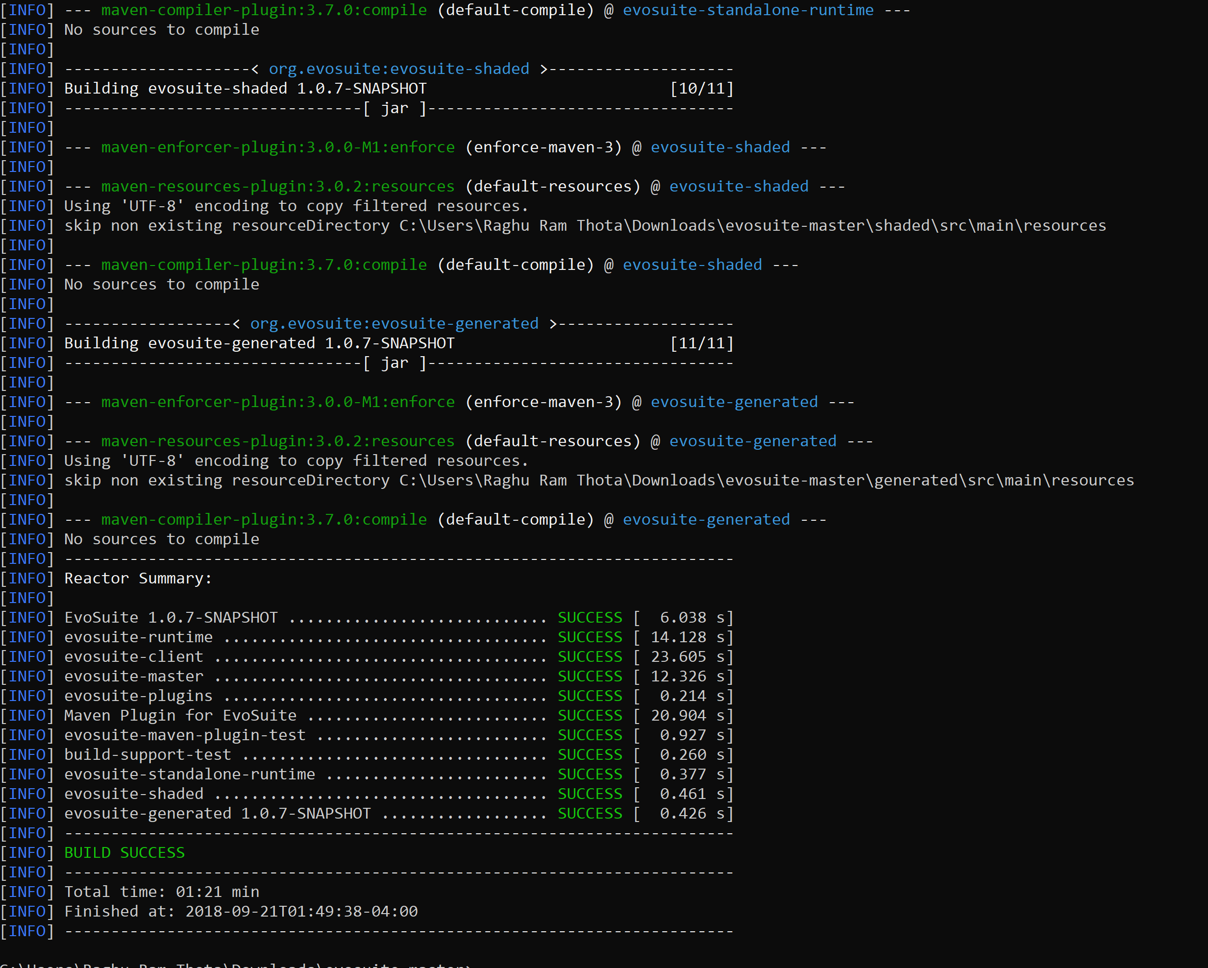

mvn package

Ti runs for 5-7 mins and there are errors for me

